* Created by [Keshav Kishor](https://confluence.oraclecorp.com/confluence/display/FusionSRE/%20%20%20%20/confluence/display/~keshav.k.kishor@oracle.com%0A), last modified on [Jan 22, 2024](https://confluence.oraclecorp.com/confluence/pages/diffpagesbyversion.action?pageId=8796461648&selectedPageVersions=2&selectedPageVersions=3)

1. Login to Jenkins [console](https://cihub.oci.oraclecorp.com/facops/facopsdevops/)
2. Click on Manage Jenkins option
3. Scroll down and click clouds option
4. Click New cloud option
5. Provide cloud Name and select docker and create docker
6. Provide a name for the Docker cloud and specify the Docker Host URI. This could be the URI of your Docker daemon (e.g., tcp://<DOCKER-HOST>:4243).
7. Configure other Docker-related settings as needed.

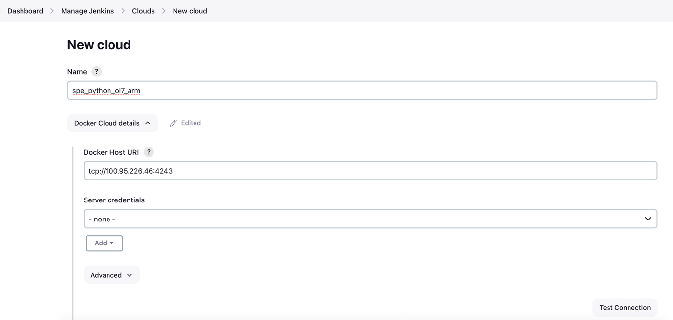

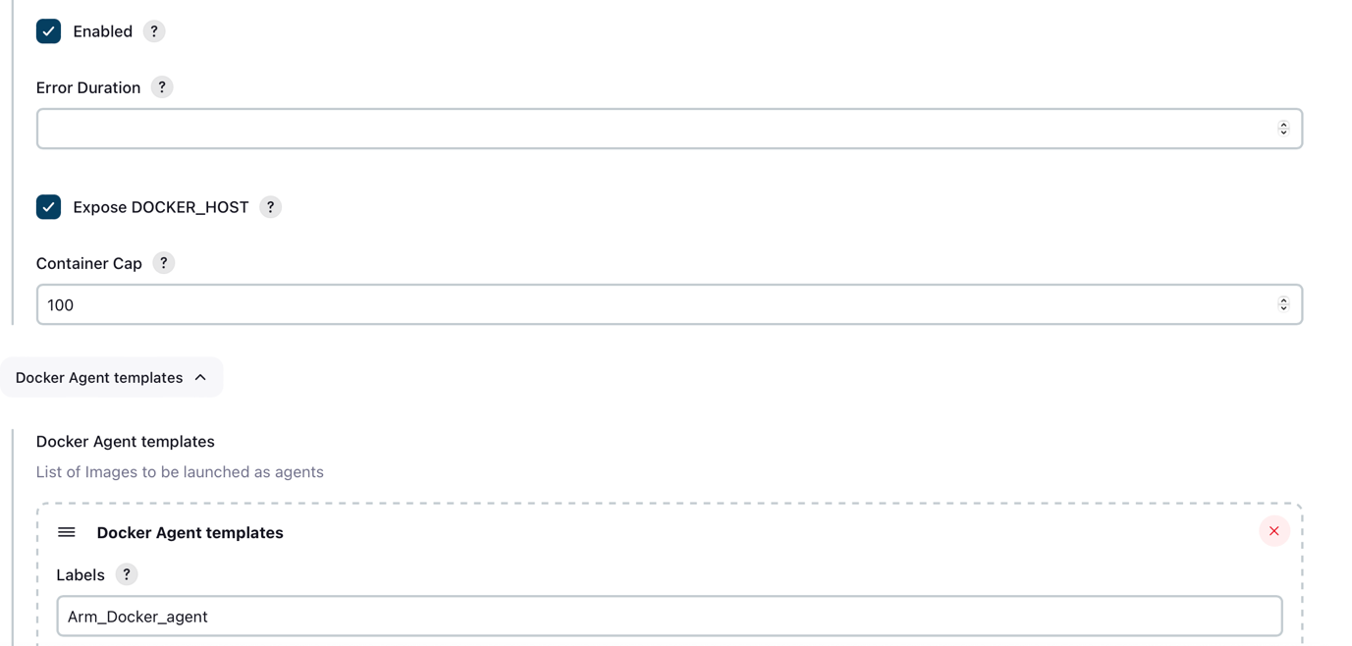

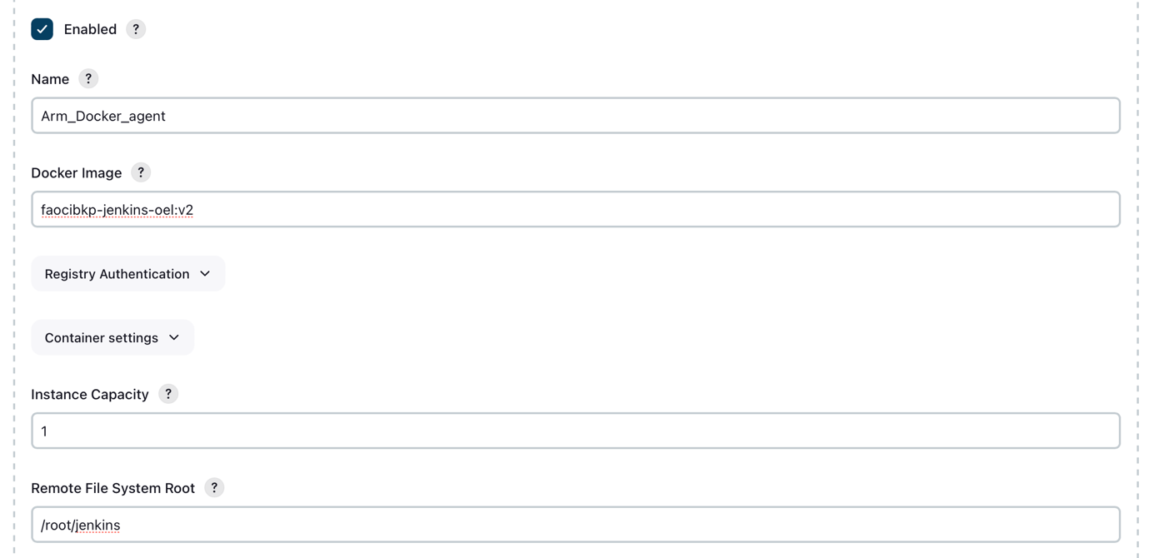

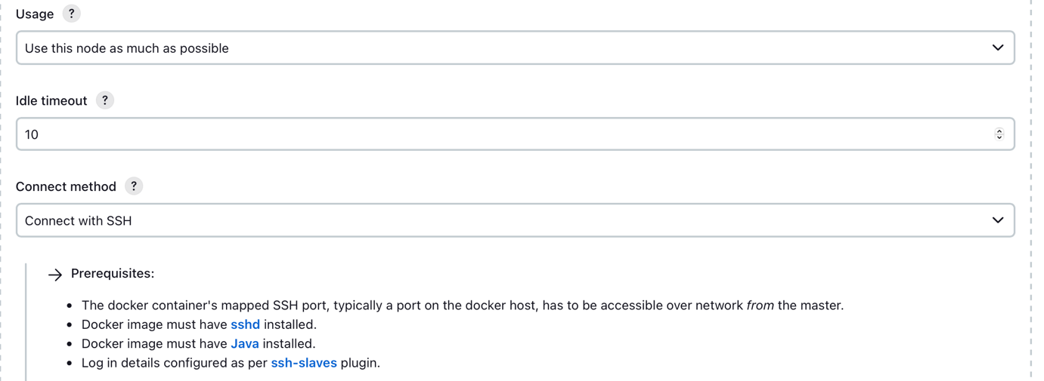

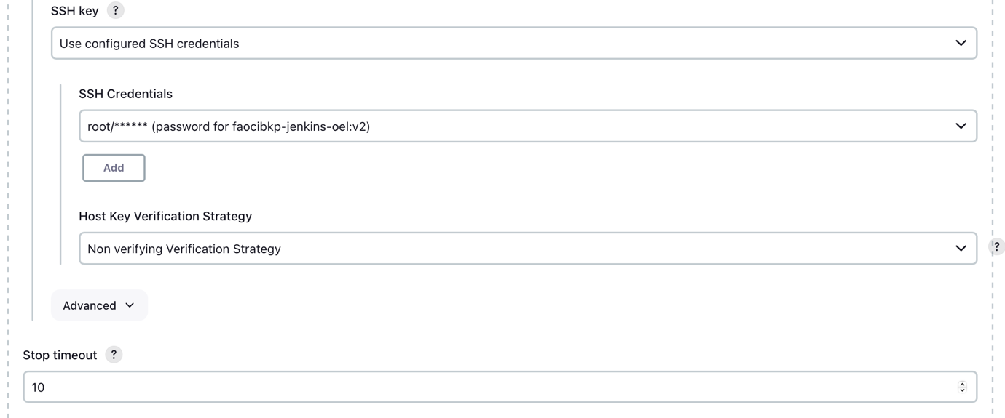

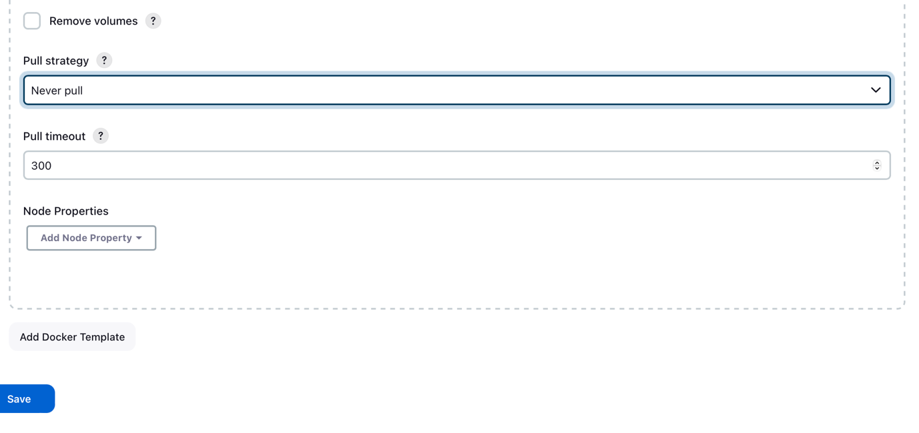

1. Login to Jenkins host :-

ARM:-phoenix315434.appsdev.fusionappsdphx1.oraclevcn.com, Intel:- phoenix130770.ad1.fusionappsdphx1.oraclevcn.com

1. If Jenkins directory to create image is not there then clone orahub repo and pick Arm based repo if host is arm based and if host is intel based pick X_86_64 directory. Link for orahub repo is:-[Link](https://orahub.oci.oraclecorp.com/faops-ocibackup-dev/jenkins-slave-docker)
2. Navigate to directory Jenkins and look for docker-compose.yml file if image is not there then execute command to create fresh image

 Expand source

1. Modify configuration of file "/lib/systemd/system/docker.service" and add configuration:-

 Expand source